Installation of Wordpress

Download and install a local copy of Wordpress on your own machine.

Requirements: You must have your own server environment installed first (e.g. XAMPP, WAMP, MAMP, a.o.).

## Download from wordpress.org

Go to [wordpress.org](http://wordpress.org) and download the latest version of Wordpress.

Please note that there is a .com site as well, however that one offers free online hosting of Wordpress. What we want is to download Wordpress and install on our own servers, so make sure you go to [wordpress.org](http://wordpress.org).

## Unpack the .zip file in your "root" folder

In your server’s root folder create a new folder called "wordpress". The downloaded .zip file should be unpacked into this new folder.

Hint: The root folder is typically called something like "htdocs" or "www", depending on your server installation (e.g. XAMPP/WAMP/MAMP a.o.).

## Open in browser

Now open a browser and access the new folder you just created and unpacked Wordpress into. If you called it "wordpress" as above, you access it by writing this in the URL bar:

localhost/wordpress/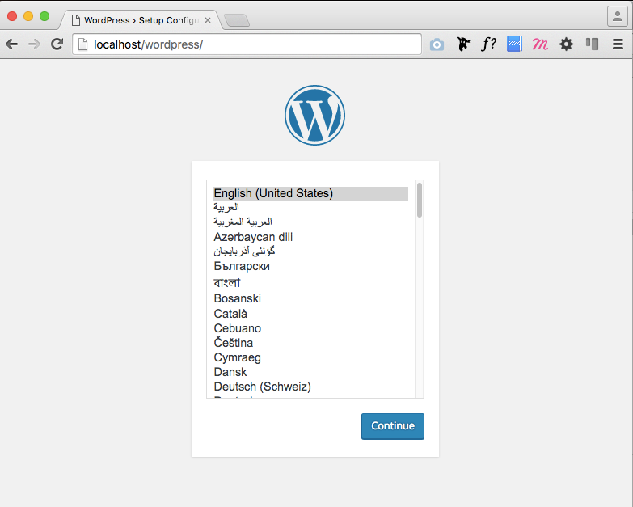

## Access the MySQL Database

In the browser, continue the Wordpress installation guide to the next step where you will be asked to prepare some data.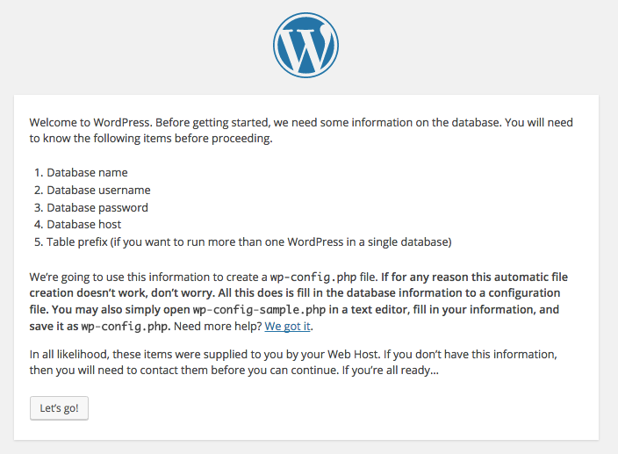

To do this, you will have to access your database. We will be using the PhpMyAdmin interface to access the MySQL database. For this to work, make sure that you have MySQL running in your control panel.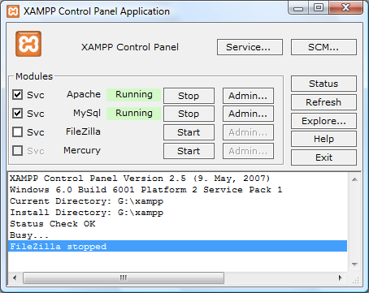

Depending on your server package, try the following to access PhpMyAdmin:

<http://localhost/phpmyadmin>

<http://localhost:8888/phpmyadmin>

It should look something like this: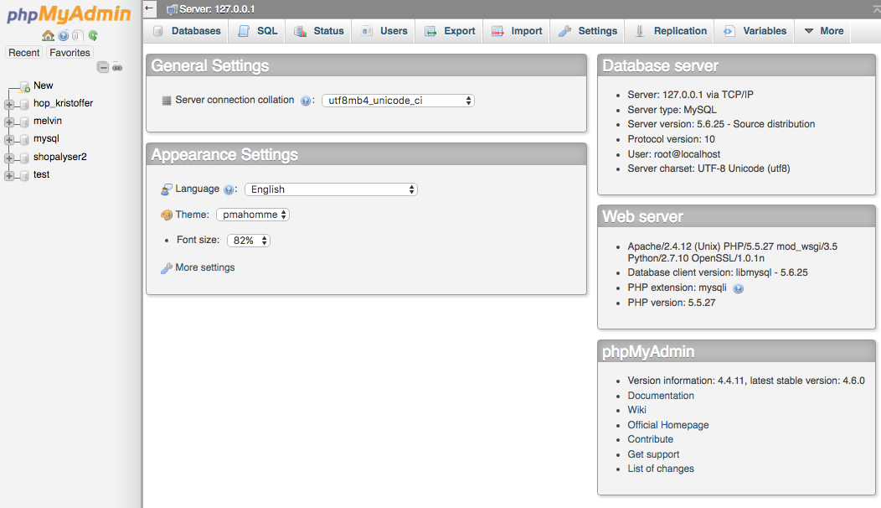

## Create a new Database user

Under the menu "Users" (DK: Brugere) choose to add a new user.

Use the following information for the user:

User name: wordpress

Host: localhost

Password: wordpress

Re-type: wordpress

Under "Global privileges" select "Check All".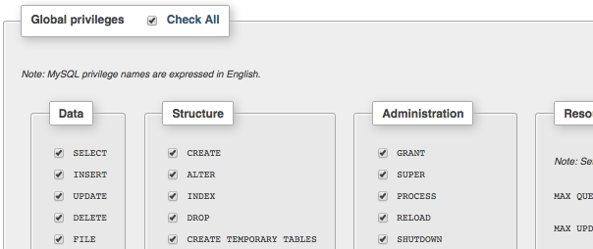

Press the "Go" button to create this user.

## Create a new database

The last thing we need is to create a new database that Wordpress can write to.

Under "Databases" create a new one called "wordpress".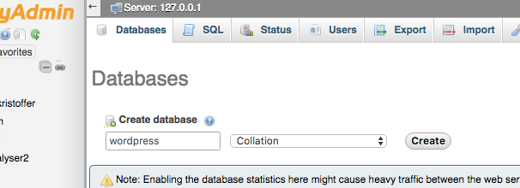

## Insert database info in Wordpress installer

Go back to the Wordpress installer and press "Let’s go!".

Fill out the form with the following information: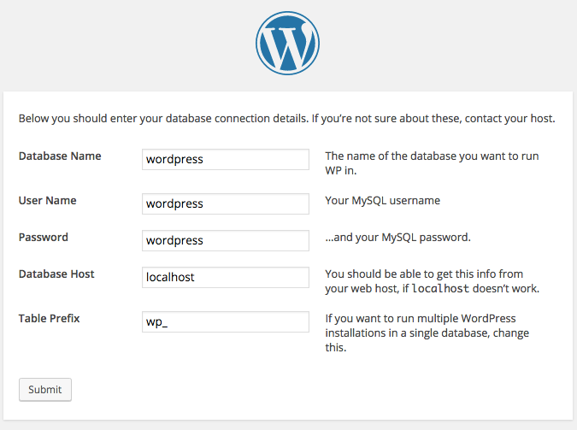

## Run the installer

Now all should be set and you can press the "Run the install" button.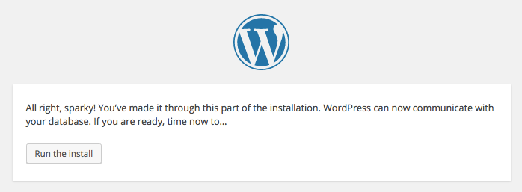

On the next page you will be asked for the following information:

Site title The name of your site, can easily be changed later

Username The name you wish to log into Wordpress with (e.g. "admin")

Password Your password for Wordpress. Choose one you can remember, maybe write it down.

Your Email So you can reset your password if lost. Might not work for all servers.

SEO Visibility Sets up a robots.txt file. Makes no difference since we are installing locally

## Log in to Wordpress

You are now ready to log into the Wordpress system. To access it from the browser:

The frontend of the system: [localhost/wordpress/](http://localhost/wordpress/)

The admin part: [localhost/wordpress/wp-admin/](http://localhost/wordpress/wp-admin/)